

Department of Polytechnic
FY-CSE Div-II

Course: Basic Electrical and Electronic Engineering

Self-Learning Assessment (SLA) Microproject

LED ON/OFF using VJT

Project Members:

SR. No. | Roll No. | PRN | Name of Student
1. | 52 | 1262251593 | Saransh Pathak
2. | 68 | 1262252737 | Mrudun Samant
3. | 77 | 1262250130 | Yajat Patil
4. | 3 | 1262250464 | Tanay Ranka

Course Teacher: Prof. Preeti Komati
1. Introduction:
This project demonstrates the use of a Bipolar Junction Transistor (BJT) as a switch to control the ON and OFF state of an LED. Transistors are fundamental components in electronics and are widely used in switching and amplification applications.
This project helps in understanding how electronic components can be used to control circuits efficiently with low power input signals.
2. Objective of the Project:
• To understand the working of a BJT as a switch
• To design a simple LED ON-OFF control circuit
• To learn basic circuit connections and component usage
• To study how current flow is controlled using a transistor
3. Scope of the Project:
• Used in basic electronic learning and demonstrations
• Applicable in switching circuits in real-world electronics
• Forms the foundation for advanced circuits like relays and automation systems
• Can be extended to control larger devices using transistors
4. Working Principle:
A BJT transistor works as a switch by operating in two regions:
- Cut-off Region (OFF state):
When no base current is applied, the transistor does not conduct, and the LED remains OFF.
- Saturation Region (ON state):
When sufficient base current is applied, the transistor allows current to flow from collector to emitter, turning the LED ON.
Thus, a small input current at the base controls a larger current in the circuit, enabling switching action.

5. Applications
• Used in electronic switching circuits
• LED indicators and display systems
• Digital logic circuits
• Microcontroller-based control systems
• Automation and control devices
PHOTOGRAPHS OF THE PHYSICAL PROJECT
Instructions: Insert clear and properly labelled images of the completed project.
1.LED OFF View of the Project
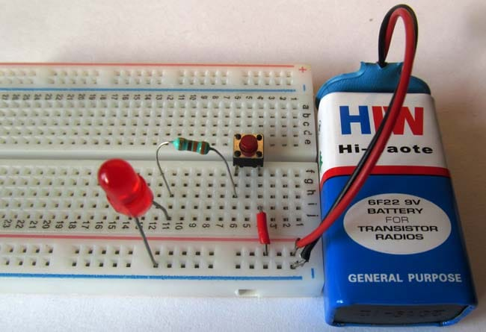

2. LED ON View of the Project
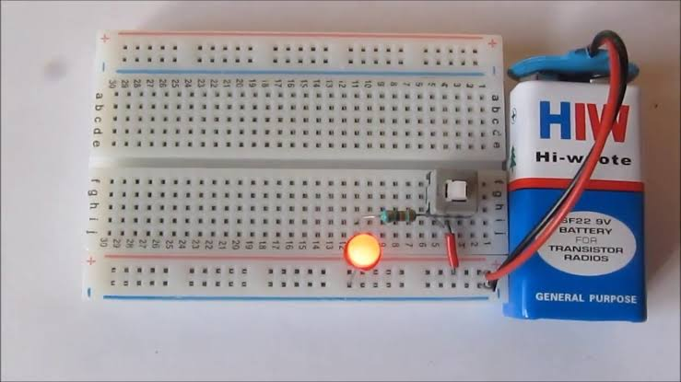
Microproject Evaluation Rubric (25 Marks)
Project Member | Implementation / Development (5 Marks) | Documentation &  Report Quality  (5 Marks) | Teamwork /Individual Contribution (5 Marks) | Demonstration (10 Marks) | Total (25 Marks)
Saransh Pathak
Mrudun Samant
Yajat Patil
Tanay Ranka

Prof. Preeti Komati
Name & Signature of Course Teacher

